BEC uses laser cutting equipment from German company, LPKF. The system has been specifically designed to manufacture stainless steel SMD solder paste and adhesive stencils. The result is a stencil of unsurpassed quality and accuracy. The system is also capable of manufacturing other precision thin metal parts such as encoder wheels, masks for projectors and much more.

**[Quote Now](https://www.becman.com/index.php?page=orderonline)**

| **Framed size(mm)** | **Usable size(mm)** | **Price** | **Freight** |
| --- | --- | --- | --- |
| 370 x 470 | 190 x 290 | $98.00 | $30.00 |
| 420 x 520 | 240 x 340 | $119.00 | $38.00 |
| 450 x 550 | 270 x 370 | $128.00 | $42.00 |
| 584 x 584 | 400 x 400 | $140.00 | $52.00 |
| 550 x 650 | 370 x 470 | $140.00 | $52.00 |
| 736 x 736 | 520 x 520 | $179.00 | $68.00 |

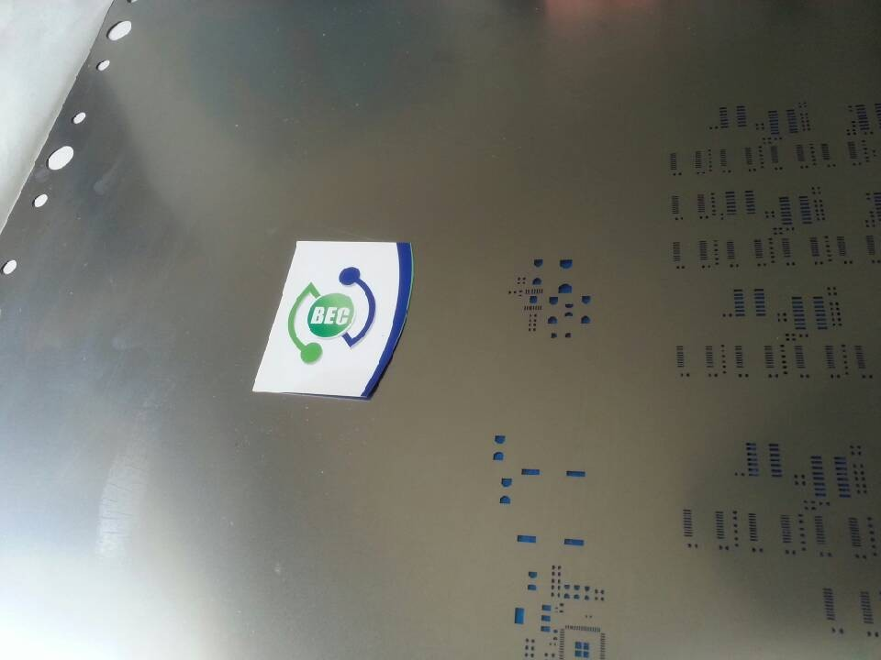

Unless otherwise specified the shim thickness used will be as follows:  
Pitch 0.4mm or 0.4mm/0.5mm BGA will use 0.1mm shim  
Pitch 0.5mm or 0.65mm BGA will use 0.12mm shim  
Pitch > 0.65mm or 0.8mm BGA will use 0.15mm shim  
If 0402 components are present will use 0.12mm shim  
Glue stencils will use 0.18mm shim.

* Unless otherwise requested the following modifications will be made to help with the correct operation of a stencil.

1. E shape pads will be applied upto 0805 package sizes.
2. If the shim thickness is not specified, it will be selected according to the design.
3. TP test points (including individual round points with no overlays) will be removed.
4. Holes on paste layer but in individual pad or hole will be removed.
5. For LED stencils the LED pads will be made according to standard rules.
6. Any special requests other than the above rules must be noted in the file